Poison Plant Test
Instructor page

Plant #1  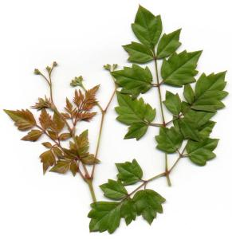  [ ] poisonous [ ✓ ] non-poisonous  Pepper Vine | Plant #2  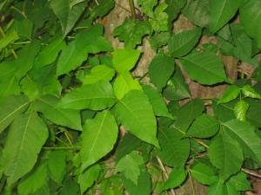  [ ✓ ] poisonous [ ] non-poisonous  Poison Ivy
Plant #3  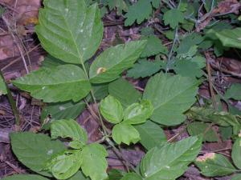  [ ] poisonous [ ✓ ] non-poisonous  Boxelder | Plant #4  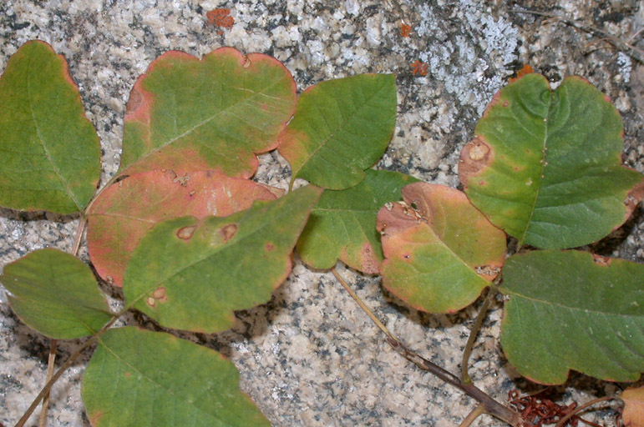  [ ✓ ] poisonous [ ] non-poisonous  Poison Oak
Plant #5  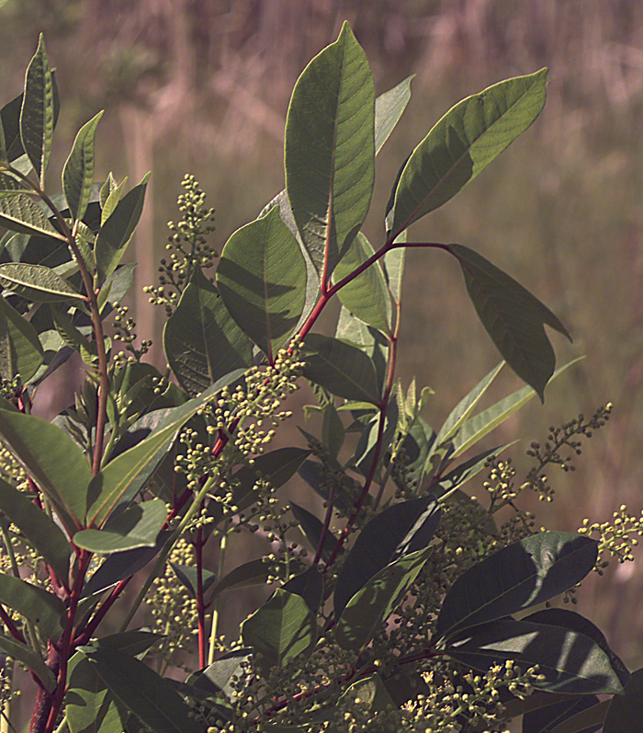  [ ✓ ] poisonous [ ] non-poisonous  Poison Sumac | Plant #6  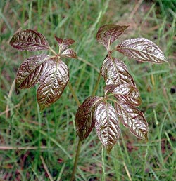  [ ] poisonous [ ✓ ] non-poisonous  Virgina Creeper
Plant #7  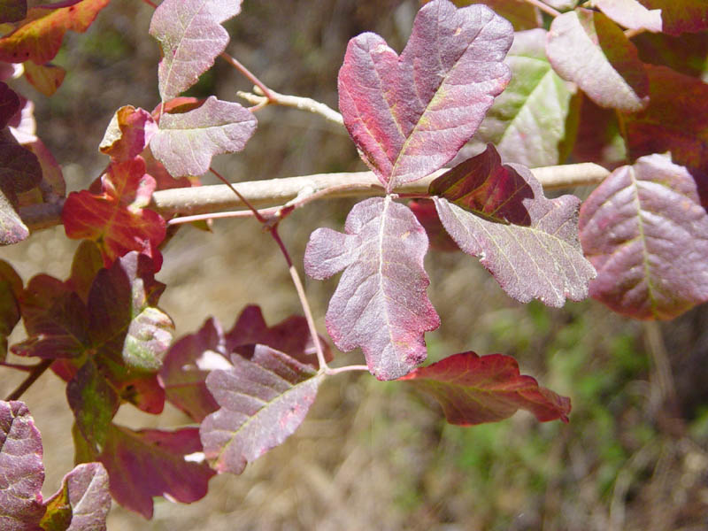  [ ✓ ] poisonous [ ] non-poisonous  Poison Oak | Plant #8  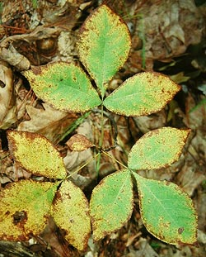  [ ] poisonous [ ✓ ] non-poisonous  Unknown non-poisonous plant

Poison Plant Test

Plant #1  [ ] poisonous [ ] non-poisonous | Plant #2  [ ] poisonous [ ] non-poisonous
Plant #3  [ ] poisonous [ ] non-poisonous | Plant #4  [ ] poisonous [ ] non-poisonous
Plant #5  [ ] poisonous [ ] non-poisonous | Plant #6  [ ] poisonous [ ] non-poisonous
Plant #7  [ ] poisonous [ ] non-poisonous | Plant #8  [ ] poisonous [ ] non-poisonous

